Name | UB Numbers | UB email | Role
Anum Ayub | 23018998 | Aayub31@bradford.ac.uk | Team Leader
Javeria Asghar | 21004304 | j.asghar@bradford.ac.uk | Speaker
Laiba Waheed | 24002607 | l.waheed3@bradford.ac.uk | Secretary
Madiha Ali Kousar | 24003351 | m.alikousar@bradford.ac.uk | Team member
Sehar Butt | 24004544 | s.butt23@bradford.ac.uk | Team member

Introduction
This instruction manual has been developed as part of the Enterprise Pro project for the Marshfield School History website. The aim of the system is to provide a structured and accessible way for storing, managing, and viewing historical information related to different schools and their records.
The website consists of multiple pages that present historical content, including text, images, and linked documents, as well as interactive features such as searchable databases. These databases allow users to efficiently find information about staff members and historical sources without needing to manually search through large amounts of data.
The system was designed based on the client’s requirement to reduce duplication of research and make historical materials more accessible to other users. In addition, the website has been structured in a way that allows it to be reused and adapted for future projects.
This instruction manual provides guidance on how to use the system and how to make changes to different parts of the website. Each section of the manual explains specific pages and features in a clear and simple way so that users with limited technical knowledge can understand and follow the instructions.

System Overview
The Marshfield School History website is a web-based application that allows users to explore historical information about different schools. The system includes multiple pages containing text, images, and hyperlinks to historical documents.
In addition, the system includes two searchable databases: the Staff database and the Sources database. These allow users to search for specific information and access relevant records efficiently.

System Requirements
To use this system, the following are required:
- A device such as a laptop or computer
- An internet connection
- A web browser (e.g. Google Chrome, Microsoft Edge

Accessing the System
- Open a web browser
- Marshfield School History
- The homepage will load automatically
- Use the navigation menu to access different pages

Page 5: Staff Database
4. Using the Staff Page
The Staff page allows users to search for staff records stored in the system database by applying different filters.
Steps to Use the Staff Page
- Open the website in a web browser
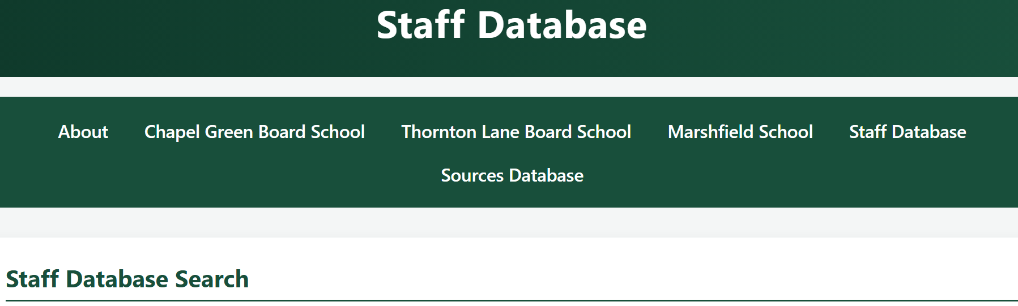
- From the navigation menu at the top of the page, click “Staff Database”
- The Staff Search form will appear
Selecting Search Filters
Users can search using one or more of the following fields:
- School Name
Select a school from the dropdown list (e.g. Marshfield School)
- Department
Select a department (e.g. Junior, Infant, Admin)
- Last Name
Type a surname into the text box
- Position
Select a staff role (e.g. Head Mistress, Assistant Mistress)
- Start Year
Enter a year value to filter records
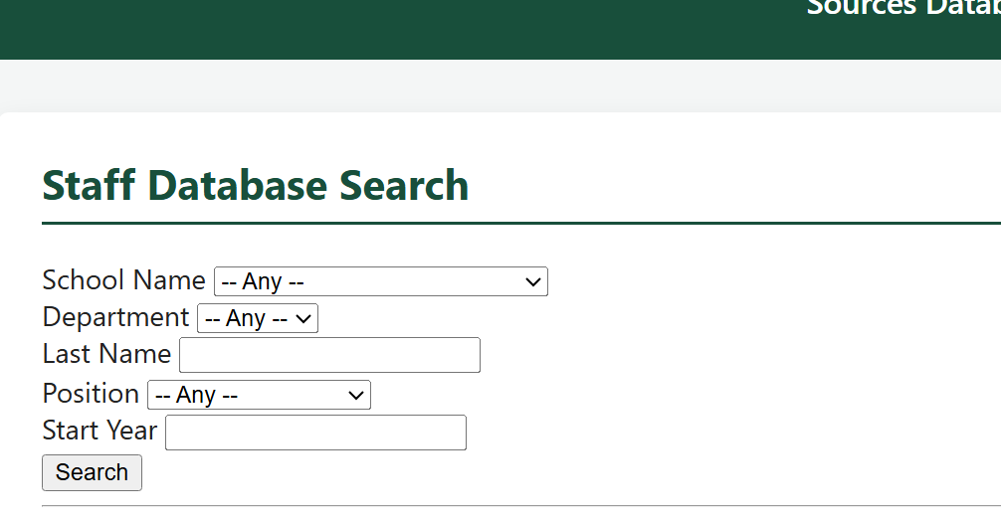
Performing a Search
- After selecting the required filters, click the Search button
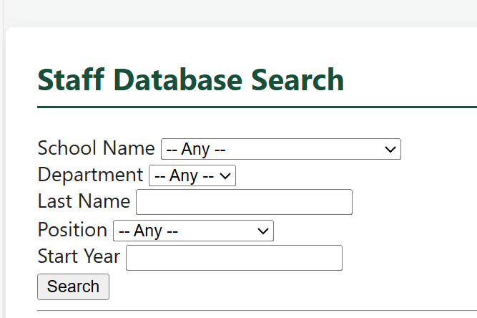
- The system will process the request and display the results below
Viewing Results
- The results will appear in the Staff Search Results section
- Each result is displayed in a structured format showing:
  - Name
  - Title
  - School
  - Department
  - Position
  - Address
  - Year recorded
  - Notes
- A summary of the total number of results is also displayed
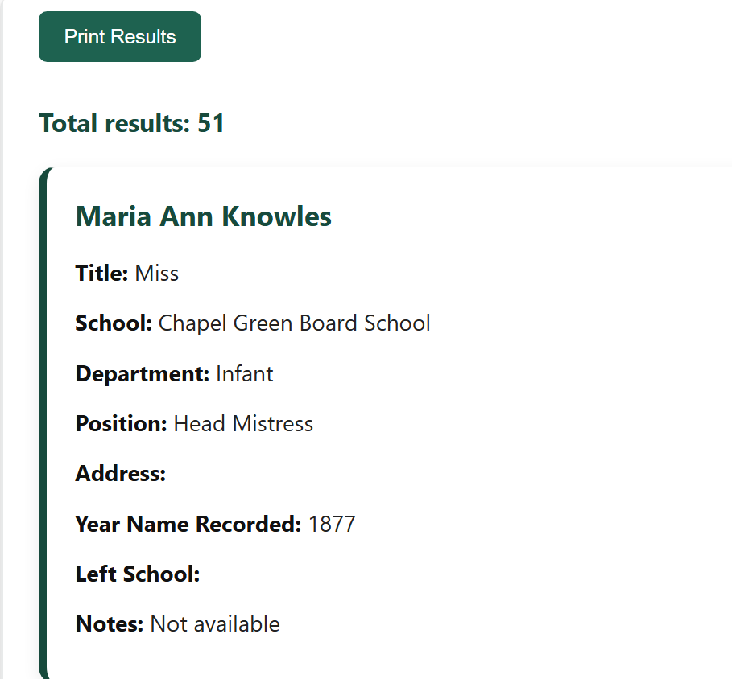
Printing Results
- Click the Print Results button
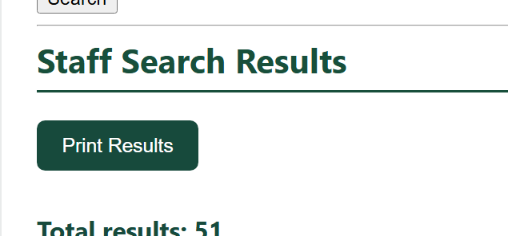
- The browser print window will open
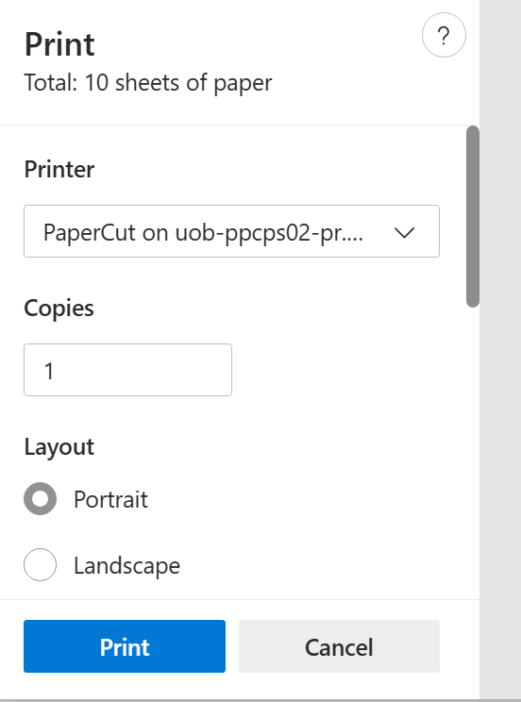
- The user can print or save the results

Expected Behaviour
- If matching records are found → they are displayed clearly
- If no records are found → a message is shown
- If no filters are selected → all available records will be displayed
Notes for Users
- Searches are not case-sensitive (e.g. “smith” and “Smith” will return the same results)
- Partial names can be used (e.g. typing “Smi” will match “Smith”)
- Results will automatically scroll into view after searching
Editing and Maintaining the Staff Page
This section explains how changes can be made to the Staff page if the client or a future developer wants to update the search form, the displayed results, or the page design.
Files used for the Staff page
The Staff page uses the following main files:
- page5_staff.html contains the structure of the page, the search form, and the JavaScript search logic
- css/style.css controls the colours, layout, spacing, and styling of the page
- Supabase database table Staff stores the staff records shown in the search results
How to change text on the page
To change visible text on the Staff page, open page5_staff.html.
Text that can be changed includes:
- the page title shown in the browser tab:
<title>Staff Database</title>
- the main heading:
<h1>Staff Database</h1>
- the search section heading:
<h2>Staff Database Search</h2>
- the results heading:
<h2>Staff Search Results</h2>
- button text such as:
<button type="submit">Search</button>
and
<button type="button" onclick="printResults()">Print Results</button>
After changing the text, save the file and refresh the page in the browser to view the update.
How to change the search options
The search options are written inside the form in page5_staff.html.
For example, the school names are stored inside the <select> dropdown:
<option value="Marshfield School">Marshfield School</option>
<option value="Thornton Lane Board School">Thornton Lane Board School</option>
<option value="Chapel Green Board School">Chapel Green Board School</option>
If the client wants to:
- add a new school
- remove a school
- change the wording of an option
this can be done by editing the <option> lines.
The same applies to other dropdown fields such as:
- Department
- Position
How to change the input fields
The Staff page currently contains these search fields:
- School Name
- Department
- Last Name
- Position
- Start Year
If a field needs to be added, removed, or renamed, this must be changed in two places:
1. In the HTML form
This controls what the user sees on the page.
For example:
<label>Last Name</label>
<input type="text" id="LastName" name="LastName">
2. In the JavaScript search logic
This controls how the search is sent to the database.
For example:
const lastName = document.getElementById("LastName").value.trim();
and
if (lastName !== "") {
query = query.ilike("Last Name", `%${lastName}%`);
}
If a new search field is added, both the HTML form and the JavaScript query must be updated.
How to change the database search logic
The Staff page connects to Supabase and searches the Staff table.
This line starts the search:
let query = client.from("Staff").select("*");
The filters are then applied depending on what the user enters.
Examples:
query = query.eq("School Name", schoolName);
This means the search will only show records with the exact selected school name.
query = query.ilike("Last Name", `%${lastName}%`);
This means the search will look for any last name containing the text typed by the user.
If the client wants to change how searching works, the JavaScript query conditions can be edited.
This may be needed if:
- a database column name change
- a new filter is added
- the search should become stricter or broader
How to change the results shown on the page
The search results are built in JavaScript inside the data.forEach(row => { ... }) section.
Each result currently shows:
- First Name
- Last Name
- Title
- School
- Department
- Position
- Address
- Year Name Recorded
- Left School
- Notes
For example:
<span class="result-label">School:</span> ${row["School Name"] || ""}
If the client wants to:
- remove a field from the results
- add another field from the database
- change the order of information shown
this section should be edited.
How to change the styling and design
The design of the page is controlled by the linked CSS file:
<link rel="stylesheet" href="css/style.css">
To change the appearance of the page, open css/style.css.
This file can be edited to change:
- colours
- fonts
- spacing
- button appearance
- result box layout
- header and navigation design
For example, if the client wants a different colour scheme or bigger text, this should be changed in the CSS file.
How the print button works
The print button uses this function:
function printResults() {
window.print();
}
This opens the browser print window and allows the user to print the search results.
If the client no longer wants this feature, the print button or the function can be removed.
Important maintenance notes
When making changes to the Staff page, the following should be checked:
- the Supabase table name is still correct
- the database column names match the code exactly
- any new form field is also added to the JavaScript logic
- the page is tested after changes are made
If the HTML form is changed without updating the JavaScript, the search may stop working properly.
Summary
The Staff page can be maintained by editing:
- page5_staff.html for text, form fields, and search logic
- css/style.css for styling and layout
- the Supabase Staff table for the data itself
This makes the page flexible and allows future updates to be made if the client wants to add more records, change the design, or improve the search features.

Page 6: Sources Database
The Sources page allows users to search for historical source records stored in the system database. Users can apply filters to narrow down the search and view matching source information.
Steps to Use the Sources Page
- Open the website in a web browser.
- From the navigation menu at the top of the page, click “Sources Database”.
- The Sources Database Search form will appear.
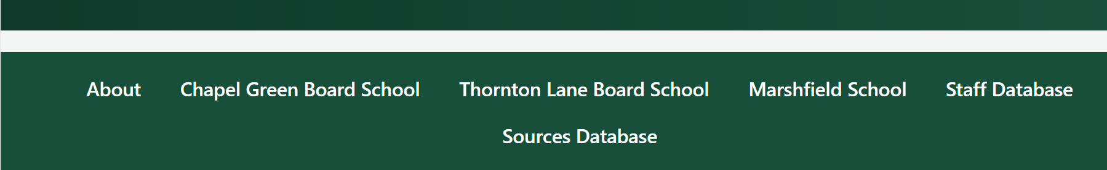
Selecting Search Filters
Users can search using one or more of the following fields:
- School Name
Select a school from the dropdown list, such as Marshfield School, Thornton Lane Board School, or Chapel Green Board School.
- Source Type
Select the type of source, such as Logbook, Admissions Register, Photograph, or Map.
- Department
Select a department, such as Junior, Infant, or Admin.
- Keyword
Type a word or phrase into the keyword box to search for matching text in the source title or notes.
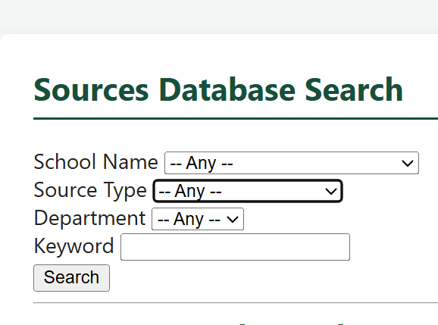
Performing a Search
- After selecting the required filters, click the Search button.
- The system will process the request and display the results below the form.
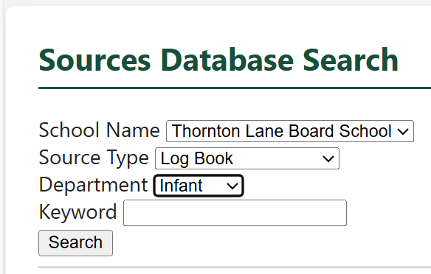
Viewing Results
The results will appear in the Sources Search Results section. Each result is displayed in a structured format and may include:
- Source title
- Source type
- School
- Department
- Notes
- Hyperlink to view the source
A summary showing the total number of matching results is also displayed.
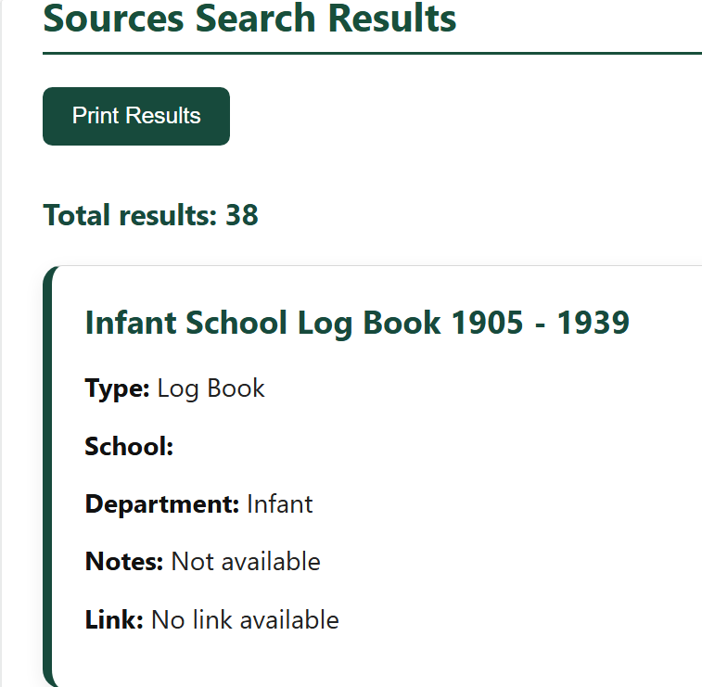
Opening a Source Link
If a record contains a hyperlink, the user can click “View Source” to open the source in a new browser tab.
If no hyperlink is available, the system will display “No link available”.
Printing Results
The page also contains a Print Results button.
- Click Print Results

- The browser print window will open
- The user can then print or save the results
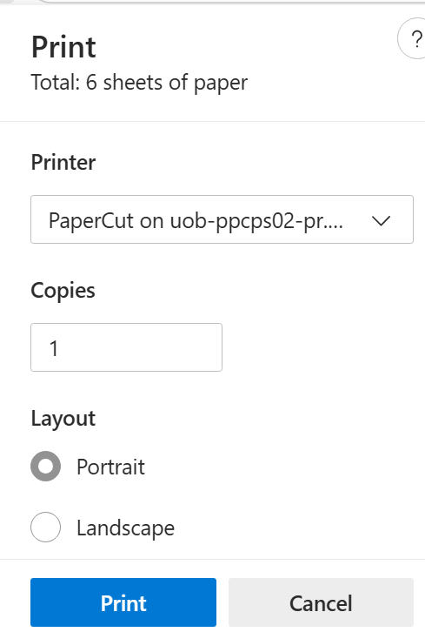
Expected Behaviour
- If matching sources are found, they will be displayed clearly in the results section.
- If no matching sources are found, the message “No sources found” will be displayed.
- If no filters are selected, all available records may be shown depending on the stored data.
Notes for Users
- Searches are not case-sensitive, so uppercase and lowercase letters are treated the same.
- The keyword search checks both the Source field and the Notes field.
- After the search is completed, the page automatically scrolls down to the results section.
Editing and Maintaining the Sources Page
This section explains how the Sources page can be updated if the client or a future developer wants to change the page text, search filters, search logic, displayed results, or design.
Files used for the Sources page
The Sources page uses the following main parts:
- page6_sources.html this contains the page structure, the search form, and the JavaScript search logic
- css/style.css controls the design, layout, colours, and styling
- Supabase database table sources store the source records shown in the search results.
How to change text on the page
To change the visible text on the Sources page, open page6_sources.html.
Examples of text that can be changed include:
- the browser tab title:
<title>Sources Database</title>
- the main page heading:
<h1>Sources Database</h1>
- the search section heading:
<h2>Sources Database Search</h2>
- the results heading:
<h2>Sources Search Results</h2>
- button text such as:
<button type="submit">Search</button>
and
<button type="button" onclick="printResults()">Print Results</button>
After editing the text, save the file and refresh the browser to check the changes.
How to change the search options
The dropdown search options are written in the form inside page6_sources.html.
For example, the source type options are written as:
<option value="Log Book">Log Book</option>
<option value="Admissions Register">Admissions Register</option>
<option value="Photograph">Photograph</option>
<option value="Map">Map</option>
If the client wants to add, remove, or rename an option, these <option> lines can be edited.
The same applies to other dropdowns such as:
- School Name
- Department
- Source Type
How to change the input fields
The Sources page currently includes these search fields:
- School Name
- Source Type
- Department
- Keyword
If one of these fields needs to be added, removed, or renamed, the changes must be made in two places.
1. In the HTML form
This controls what the user sees.
For example:
<label>Keyword</label>
<input type="text" id="Keyword" name="Keyword">
2. In the JavaScript search logic
This controls how the value is used in the database search.
For example:
const keyword = document.getElementById("Keyword").value.trim();
and
if (keyword !== "") {
query = query.or(`Source.ilike.%${keyword}%,Notes.ilike.%${keyword}%`);
}
If a new field is added, both the form and the JavaScript logic must be updated.
How to change the database search logic
The Sources page connects to Supabase and searches the sources table.
This line begins the database search:
let query = client.from("sources").select("*");
The selected filters are then applied to the query.
Examples include:
query = query.eq("School", schoolName);
This means the selected school must match exactly.
query = query.eq("Source type", sourceType);
This means the selected source type must match exactly.
query = query.or(`Source.ilike.%${keyword}%,Notes.ilike.%${keyword}%`);
This means the keyword will search both the Source and Notes columns without being case-sensitive.
This part should be edited if:
- a database column name changes
- a new search filter is added
- the keyword search needs to include other columns
- the client wants the search behaviour to change
How to change the results shown on the page
The search results are created inside the JavaScript data.forEach(row => { ... }) section.
Each result currently shows:
- Source title
- Type
- School
- Department
- Notes
- Hyperlink
For example:
<span class="result-label">Department:</span> ${row["Department"] || ""}
and
${row["Hyperlink"] ? `<a href="${row["Hyperlink"]}" target="_blank">View Source</a>` : "No link available"}
If the client wants to change what appears in the results, this section can be edited.
This may include:
- removing fields
- adding extra fields from the database
- changing the order of fields
- changing the hyperlink text
How to change the styling and design
The appearance of the Sources page is controlled by this CSS file:
<link rel="stylesheet" href="css/style.css">
To change the design, open css/style.css.
This file can be used to update:
- colours
- fonts
- spacing
- button design
- search box layout
- result box style
- navigation and header appearance
How the print button works
The print button uses this JavaScript function:
function printResults() {
window.print();
}
When clicked, it opens the browser print window so the results can be printed or saved.
If the client no longer wants this feature, the button or function can be removed.
Important maintenance notes
When making changes to the Sources page, the following should always be checked:
- the Supabase table name is still correct
- the database column names still match the code exactly
- any new field added to the form is also added to the JavaScript search logic
- hyperlinks still open correctly
- the page is tested after changes are made
If the form is changed without updating the JavaScript, the search may stop working properly.
Summary
The Sources page can be maintained by editing:
- page6_sources.html for page text, search fields, and JavaScript logic
- css/style.css for design and appearance
- the Supabase sources table for the stored data
This allows the page to be updated in future if the client wants to change the design, improve the search options, or add more source records.

